Out & About: Newport Chamber of Commerce gets new digs in historic building

The Depot Building in downtown Newport will be the new home of the Newport Area Chamber of Commerce once renovations are complete. (Courtesy of the Newport Area Chamber of Commerce) Courtesy of the Newport Area Chamber of Commerce

By LIZ SAUCHELLI

*Valley News* Staff Writer

Published: 2/25/2023 8:10:27 PM

Modified: 2/25/2023 8:09:24 PM

A building in Newport’s historic district will become the new — and permanent — home for the Newport Area Chamber of Commerce.

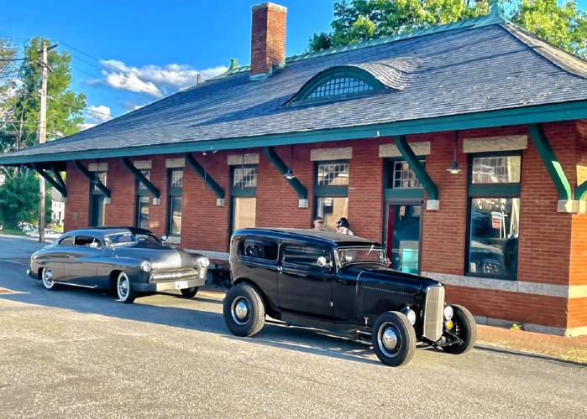

Earlier this month, Bar Harbor Bank & Trust gifted the Depot Building, located at 19 Depot St. in downtown Newport, to the chamber. Depot Street is right off Main Street.

“We are so excited to eventually have a permanent home,” said Shannon MacMichael, executive director of the chamber.

The nonprofit organization currently has a small space on Main Street in the Library Arts Center Annex location, but it is not very visible.

“We’ve always had a donated space,” MacMichael said.

The Depot Building, built in 1897, served as the B&M Railroad passenger station until 1958, according to a news release from the chamber. Over the years it has held a variety of businesses, including a day care center. It has been vacant for around four years, MacMichael said.

“Unfortunately there was vandalism,” she said.

Walls, doors and other parts of the building were damaged.

“We’ve definitely got our work cut out for us,” MacMichael said.

MacMichael and chamber board members are looking forward to that work. Volunteers have recently started gutting the building. As they started to pull apart a damaged drop-down ceiling, they discovered “beautiful old woodwork and windows,” which provided a glimpse of what the building once was — and could be again.

“It’s kind of nice that we’re going to gut it and start from scratch … and try to get it as close to what it was originally,” MacMichael said. “Because it was beautiful.”

The chamber is currently working with the New Hampshire Preservation Alliance to figure out grants they can apply for and other funding sources. MacMichael also said they will ask volunteers for help, in addition to private donations.

“We really have no idea,” how much it will cost she said, adding that it’s too soon to set an official timetable for when the chamber offices will move to the space. “We’re probably thinking about a year and a half, probably all of 2024 when everything is said and done.”

In addition to housing offices, MacMichael said the Depot Building will serve as a welcome center and there will be a conference area that people in town can use.

While they may not be able to use the inside yet, they can use the lot outside. CarNutz Cruise Nights will be held from 6 to 8 p.m. every second and fourth Monday from May through September.

Chamber officials have been discussing a more permanent home since MacMichael became executive director last January. When Bar Harbor suggested the Depot Building, it was the perfect fit.

“We want to preserve it just as much as everyone else,” MacMichael said. “It’s a piece of history in the town.”