**[HERALD CITIZEN](https://www.wickedlocal.com/heraldcitizen/)**

**Danvers Town Meeting takes no action on warrant article to save Plains Train Station**

[**[Portrait of Jennie Oemig](https://www.wickedlocal.com/staff/6042722002/jennie-oemig/)Jennie Oemig**](https://www.wickedlocal.com/staff/6042722002/jennie-oemig/)

11/17/21

DANVERS — The future of the former Plains Train Station building is in jeopardy as a citizens’ petition failed to garner a two-thirds vote of Danvers Town Meeting on Monday night.

The former depot building, built in 1868, is located at 22 Cherry St., Danvers, on a lot owned and controlled by Townsend Oil.

The citizens' petition sought to allow for the old station to be acquired by the town at no cost, then relocated to the parking lot at 10 Hobart St., restored and taken under the care of the Danvers Select Board.

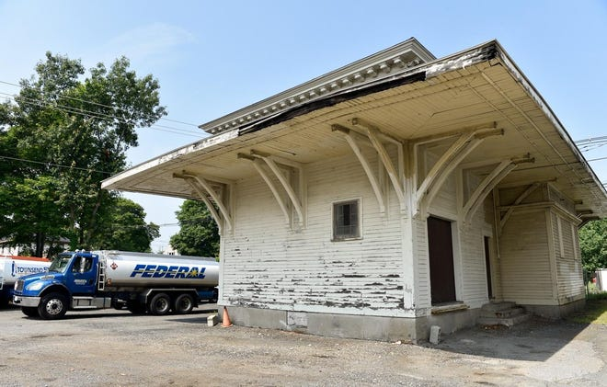

Louis George, a member of the Danvers Planning Board, spearheaded the movement to restore the depot building.

“Like many of you, I grew up in Danvers, and also, like many of you, I’ve also seen many of the buildings that made up Danvers history disappear over time,” he told Town Meeting members. “This is really the last opportunity to save the last remaining train station in Danvers.”

Earlier this year, a permit was pulled to demolish the structure, but it was temporarily spared from that fate in late July, when the Danvers Preservation Commission deemed it worthy of preservation.

“There is a one-year demolition delay that is currently in effect,” George noted. “That demolition delay will remain until just this coming July. And after that, the building most likely will come down.”

A previous attempt to preserve the building in a similar manner was undertaken in 2016; however, state funding for that project failed to materialize.

George said the costs associated with moving and restoring the building, estimated at $1.2 million, could be raised through borrowing.

“The town is well-situated to bear the cost of this through borrowing,” he said. “The town’s bond rating is solid. And the plan for this station, as well, is not to serve as a museum, but is to be an income-generating property. … The building would be a good candidate potentially for a restaurant, for office space.”

Mike Powers, Town Meeting member representing Precinct 6, said while he loves the building, there seems to be no good, viable option given the availability of land and the relative cost to move, renovate and to make the building whole.

“Another big component that is missing is maintenance,” he pointed out. “Once we get this and once we renovate it, we own it. We’re responsible for it. We have to keep it safe. … As much as I would love to support this, I cannot. This will not be successful. This will cost the town a lot of money over the long run, and it’s inherently unfair to those in the surrounding area that are relying on this lot.”

Town archivist Richard Trask said retaining historical structures like the old depot building help give the town character and preserve its history and legacy.

“We in Danvers must be progressive while retaining, through planning, preserving and adaptive reuse, the best of our heritage and neighborhoods,” he said. “Our history in preservation is mixed at best. Each year, with less usable land and more development pressures, we continue to lose major historic chunks of our community. … You’re being asked to do something that Danvers seldom has done, but which many other enlightened communities do on occasion - to save a piece of our town heritage and make it into something generations into the future will be able to view and enjoy.”